**Cognizant Week-5_HandsOn**

**Exercise: Creating Microservices for Account And Loans**

**Code For Loan Microservice:**

**LoanApplication.java:**

package com.cognizant.loan;  
  
import org.springframework.boot.SpringApplication;  
import org.springframework.boot.autoconfigure.SpringBootApplication;  
  
@SpringBootApplication  
public class LoanApplication {  
 public static void main(String[] args) {  
 SpringApplication.*run*(LoanApplication.class, args);  
 }  
}

**LoanController.java:**

package com.cognizant.loan.controller;  
  
import org.springframework.web.bind.annotation.*;  
import java.util.Map;  
  
@RestController  
@RequestMapping("/loans")  
public class LoanController {  
  
 @GetMapping("/{number}")  
 public Map<String, Object> getLoanDetails(@PathVariable String number) {  
 return Map.*of*(  
 "number", number,  
 "type", "car",  
 "loan", 400000,  
 "emi", 3258,  
 "tenure", 18  
 );  
 }  
}

**Application.Properties:**

server.port=8081

**Pom.xml**:

<project xmlns="http://maven.apache.org/POM/4.0.0"  
 xmlns:xsi="http://www.w3.org/2001/XMLSchema-instance"  
 xsi:schemaLocation="http://maven.apache.org/POM/4.0.0 http://maven.apache.org/xsd/maven-4.0.0.xsd">  
 <modelVersion>4.0.0</modelVersion>  
 <groupId>com.cognizant</groupId>  
 <artifactId>loan</artifactId>  
 <version>0.0.1-SNAPSHOT</version>  
 <packaging>jar</packaging>  
 <name>loan</name>  
 <description>Demo project for Spring Boot</description>  
 <parent>  
 <groupId>org.springframework.boot</groupId>  
 <artifactId>spring-boot-starter-parent</artifactId>  
 <version>3.2.4</version>  
 <relativePath/> <!-- lookup parent from repository -->  
 </parent>  
 <dependencies>  
 <dependency>  
 <groupId>org.springframework.boot</groupId>  
 <artifactId>spring-boot-starter-web</artifactId>  
 </dependency>  
 <dependency>  
 <groupId>org.springframework.boot</groupId>  
 <artifactId>spring-boot-devtools</artifactId>  
 <scope>runtime</scope>  
 </dependency>  
 </dependencies>  
 <build>  
 <plugins>  
 <plugin>  
 <groupId>org.springframework.boot</groupId>  
 <artifactId>spring-boot-maven-plugin</artifactId>  
 </plugin>  
 </plugins>  
 </build>  
</project>

**Output**:

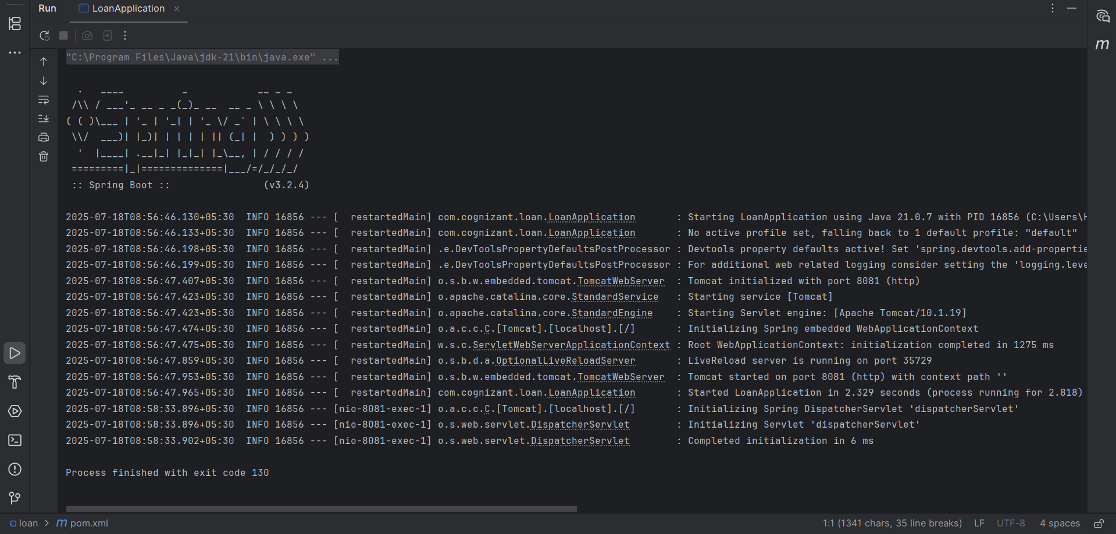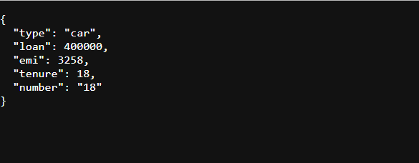

**Code For Accounts Microservice**:

**Code**:

**AccountApplication.java**:

package com.cognizant.account;  
  
import org.springframework.boot.SpringApplication;  
import org.springframework.boot.autoconfigure.SpringBootApplication;  
  
@SpringBootApplication  
public class AccountApplication {  
 public static void main(String[] args) {  
 SpringApplication.*run*(AccountApplication.class, args);  
 }  
}

**AccountController.java**:

package com.cognizant.account.controller;  
  
import org.springframework.web.bind.annotation.*;  
import java.util.Map;  
  
@RestController  
@RequestMapping("/accounts")  
public class AccountController {  
  
 @GetMapping("/{number}")  
 public Map<String, Object> getAccountDetails(@PathVariable String number) {  
 return Map.*of*(  
 "number", number,  
 "type", "savings",  
 "balance", 234343  
 );  
 }  
}

**Pom.xml**:

<project xmlns="http://maven.apache.org/POM/4.0.0"  
 xmlns:xsi="http://www.w3.org/2001/XMLSchema-instance"  
 xsi:schemaLocation="http://maven.apache.org/POM/4.0.0 http://maven.apache.org/xsd/maven-4.0.0.xsd">  
 <modelVersion>4.0.0</modelVersion>  
 <groupId>com.cognizant</groupId>  
 <artifactId>account</artifactId>  
 <version>0.0.1-SNAPSHOT</version>  
 <packaging>jar</packaging>  
 <name>account</name>  
 <description>Demo project for Spring Boot</description>  
 <parent>  
 <groupId>org.springframework.boot</groupId>  
 <artifactId>spring-boot-starter-parent</artifactId>  
 <version>3.2.4</version>  
 <relativePath/> <!-- lookup parent from repository -->  
 </parent>  
 <dependencies>  
 <dependency>  
 <groupId>org.springframework.boot</groupId>  
 <artifactId>spring-boot-starter-web</artifactId>  
 </dependency>  
 <dependency>  
 <groupId>org.springframework.boot</groupId>  
 <artifactId>spring-boot-devtools</artifactId>  
 <scope>runtime</scope>  
 </dependency>  
 </dependencies>  
 <build>  
 <plugins>  
 <plugin>  
 <groupId>org.springframework.boot</groupId>  
 <artifactId>spring-boot-maven-plugin</artifactId>  
 </plugin>  
 </plugins>  
 </build>  
</project>

**Output**:

